New distributional records in Gonatodes albogularis (Squamata: Sphaerodactylidae) a transplanted species for eastern Colombia

Nuevos registros de distribución de Gonatodes albogularis (Squamata: Sphaerodactylidae), unaespecies trasplantada al oriente de Colombia

José Rancés Caicedo-Portilla^{1, 3}, Doris L. Gutiérrez-Lamus^{2, 3 *}

¹Instituto Amazónico de Investigaciones Científicas-SINCHI, sede principal, Avenida Vásquez Cobo entre calles 15 y 16, Leticia, Amazonas, Colombia. ORCID: https://orcid.org/0000-0001-5689-5657
²Instituto Amazónico de Investigaciones Científicas-SINCHI, sede de enlace, Calle 20 N° 5-44, Bogotá D. C., Colombia. ORCID: https://orcid.org/0000-0002-9801-4544
³ Grupo de Fauna Amazónica Colombiana

*Corresponding author: laurygut@gmail.com, jcaicedo@sinchi.org.co

Abstract
We documented the eastern most records in Colombia of the lizard Gonatodes albogularis. We believe that Cis-Andean records along with those presented here are accidental introductions, mainly due to the trade of goods between localities in the interior of the country and the Cis-Andean cities where the species has been found. We consider G. albogularis as a species with a Trans-Andean distribution, which will continue spreading throughout the Amazon and Orinoco regions by air and river transportation of goods, and passengers to those areas of the country. We report the second specimen with leucism in Colombia.

Keywords: Amazonia. Geographical distribution. Inírida. Mitú. Transplanted species, Yellow-headed Gecko.

Resumen
Documentamos los registros más al oriente del lagarto Gonatodes albogularis en Colombia. Creemos que los registros cis-andinos, así como los aquí presentados, corresponden a introducciones accidentales (especie trasplantada) debido principalmente al comercio de mercancías entre localidades del interior del país y las ciudades cis-andinas en donde se ha encontrado la especie. Consideramos que G. albogularis es una especie con una distribución netamente trans-andina que va a seguir dispersandose en las regiones de la Amazonia y la Orinoquia por medio del transporte aéreo y fluvial que lleva mercancías y pasajeros a estas zonas del país. Reportamos el segundo ejemplar con leucismo en Colombia.

Palabras clave: Amazonia. Distribución geográfica. Geco de cabeza amarilla. Especie trasplantada. Inírida. Mitú.

Introduction
The genus Gonatodes Fitzinger, 1843 contains 33 species (Uetz et al., 2019; Meneses-Pelayo & Ramírez, 2020; Rivero-Blanco & Schargel, 2020), nevertheless in Colombia only five species have been registered: Gonatodes albogularis, Gonatodes chucuri, G. humeralis, G. riveroi, and G. vittatus (Ayala, 1986; Sturaro & Avila Pires, 2011; Meneses-Pelayo & Ramírez, 2020). Gonatodes albogularis is a small lizard with a wide distribution. It is found in Central America, the Caribbean Islands, and northern South America, in Colombia and Venezuela (Peters & Donoso-Barros, 1970; Savage, 2002; Köhler, 2008). In Colombia, G. albogularis occurs in the Trans-Andean lowlands and in the lowlands of the eastern slopes of the Cordillera Oriental (Ayala, 1986, Sánchez et al., 1995). This small diurnal lizard lives in a wide variety of habitats, from humid tropical forests to dry tropical forests, between 0-1500 m a.s.l (Peters & Donoso-Barros, 1970). The species is frequently observed in disturbed areas, where it prefers human buildings (Rivero-Blanco, 1968; Serrano-Cardozo et al., 2007). It was introduced in Florida, USA (Krysko, 2005), San Andrés island in Colombia (Forero-Medina et al., 2006), apparently in Belize (Lee, 2000 in Jablonski, 2015), and Venezuela's Orinoco river delta (Rivas-Fuenmayor & Molina, 2003). The aim of this work is to document new Cis-Andean records of distribution of the Yellow-Headed Gecko in Colombia, and to report the second specimen with leucism in Colombia.

Materials and Methods
The field work to different locations in the Colombian Amazon was funded and carried out by Sinchi Institute. We searched for herps during the day and at night using visual encounter survey (VES). The animals were caught by hand, kept in a bag, euthanized with an overdose of 2% Roxicaine, fixed in 10% formalin, and finally preserved in 70% ethanol. The specimens are deposited in the reptile collection of Instituto Sinchi (SINCHI-R), located in Leticia city, in the Amazonas department.
The specimens were taxonomically identified by external characteristics, such as: absent eyelids; anthumeral white bar; lamellae under digits not flattened, and not wider than the digits; and the coloration pattern of males, which is characteristic for most of the species in the genus Gonatodes (Peters & Donoso-Barros 1970, Savage 2002), except in G. lichenosus and G. chucuri, which do not have sexual dichromatism (Rojas-Runjaic et al., 2010; Meneses-Pelayo & Ramírez, 2020).
A map was created using presence locations of G. albogularis as recorded in the literature and information gathered after visiting several biological collections such as Instituto de Ciencias Naturales (ICN), La Salle Museum of Natural History (MLS) and Instituto Alexander von Humboldt (IAvH).

Results
On July 6, 2015 one female (SINCHI-R-388) and a male (SINCHI-R-389) (Figure 1A) were captured on the back walls of a hotel in Inírida city, Guainía. (Table 1, Figure 2); later, on November 15th and 16th of 2015, in the same locality, we found a gecko, which at first glance was similar to one of the species of Hemidactylus (possibly H. palaichthus or H. frenatus), which are commonly found in the city. However, shortly after carefully observing the specimen, we were able to confirm that it belonged to a lightly coloured female of G. albogularis (SINCHI- R- 538), (figure 1B). The specimen was found in the same hotel under the stairs, which were made of cement and covered with white paint.
In life, the specimen SINCHI-R-538 was dorsally beige with fine reddish-brown dots; iris light brown with a beige internal ring; tail and extremities light yellow, white throat, and a yellowish venter. In alcohol, this specimen is dorsally whitish with tiny brown spots; one thin white anthumeral bar; white flanks with small pale brown spots; its regenerated tail is white; venter white with tiny grey dots, which are more visible on the ventral surface of the extremities. Due to the pattern of abnormal coloration, this specimen clearly presents a condition of leucism.
Two more females of G. albogularis were collected in the same hotel (SINCHI- R- 541 and SINCHI-R-542), both of which were cryptically coloured. In life, SINCHI-R- 541 was dorsally grey brown with dark brown spots and beige dots, and ventrally it was dark yellow. On the other hand, SINCHI-R-542 had a similar coloration to SINCHI-R-541, but also had white dots forming transversal lines on flanks and on the back (Figure 1C). When preserved in alcohol, all normally colored specimens of G. albogularis show a paler coloration than alive, but they never exhibit a whitish color.
On January 22nd and 23rd of 2017, four females were caught (SINCHI-R 886, 908-910) in Los Angeles, a village at Belén de los Andaquíes, Caquetá (Table 1, Figure 2). The specimens were captured at night, on the roofs of the houses while they were actively foraging next to Hemidactylus angulatus. At the same locality, a male with a yellowish head and blue spots on his lips was observed, but escaped when attempting to capture it.
On July 15th of 2018, two males (SINCHI-R-2727 and 2728) and one female (SINCHI-R-2729) were captured in the city of Mitú, Vaupés (Table1, Figure 2). The specimens were captured at approximately 8:00 hours, when they were basking and foraging on a wooden fence, next to the headquarters of Sinchi Institute in that locality. At that point, juveniles of this species were observed as well.
Cis-Andean records from the departments of Arauca, Meta, Caquetá, and Putumayo (Table 1, Figure 2) were found after checking Ayala (1986), Vanzolini & Williams (1962); there are specimens from Florencia city (Caquetá), deposited in the herpetological collection of La Salle Museum of Natural History which were collected by Brother Nicéforo María in 1951(MLS 513-519), and by the Brother Daniel Jesús in 1962 (MLS-13, MLS 539-540).

Discussion
The cities of Mitú and Inírida are isolated by land from the rest of the country. The connections of these cities with other locations are made by waterway through the Vaupés and Guaviare river respectively or by air, mainly from Bogotá and Villavicencio, the latter one with records of the Yellow-headed gecko (this study). The specimens from these cities confirm an eastward range extension of G. albogularis in Colombia. Our findings in Inírida represent a range extension to ca. 441 km in a straight line; and Mitú records are approximately 435 km away from between the Duda river and the Serranía de la Macarena, Meta. We believe that specimens registered on the eastern slopes of the Cordillera Oriental, from the departments of Arauca, Meta, Caquetá and Putumayo, were accidental introductions (transplanted specimens), and that the original distribution of this gecko is clearly Trans-Andean. The first Cis-Andean voucher of Gonatodes albogularis was collected in November of 1936 (MLS-7), in the municipality of Puerto Asís, Putumayo; this specimen was reported by Ayala in 1986, without an accurate date or location; we believe that this specimen was recorded on a map made by Vanzolini & Williams (1962), but it was not referenced in their list of examined specimens. Possibly this species was transplanted accidentally as a result of the trade between Puerto Asís and the interior of the country.
Other species of the genus Gonatodes have been recorded outside of their natural distribution area. For instance, G. vittatus has been recorded in Guyana (Meilink et al., 2013) and G. caudiscutatus has been registered on Chatham island (San Cristóbal) which makes part of the Galápagos island chain, as well as on several locations on the eastern flank of the Ecuadorian Andes (Carvajal-Campos & Torres-Carvajal, 2012; Sturaro & Avila-Pires, 2013).
Although animals with pigment abnormalities have a lower survival rate caused by a higher detectability to predators, and problems associated with thermoregulation due to a lesser ability to gain calories from solar radiation (Rivera et al., 2001); SINCHI-R 538 is a female and the second specimen of G. albogularis with leucism reported in Colombia; the first case was reported by Grisales-Martínez & Arias-Alvarez (2018) for a female collected in the Trans-Andean department of Antioquia.
Even though with pigmentary abnormalities the adult female collected by us had apparently found, or was luckily born in an ideal place for its survival. Crawling under the steps of the staircase, it found a place where its abnormal coloration went unnoticed. Probably, it was able to camouflage easily with the white paint on the staircase, aided by the protection that the steps offered to keep it safe from resident predators (e.g. cats).
It seems like lizards of the genus Gonatodes are very mobile, presumably using human transport; according to Rivero-Blanco (1968), G. albogularis seems to be one of the most colonizing species within the genus. For those reasons, and the new records presented here, it is highly probable that G. albogularis will continue spreading throughout the cis-Andean region of Colombia using passengers and merchandising carriers for its dispersal.

Acknowledgements
We thank Germán C. Martínez for his assistance with the distribution map, Andrés Barona for his comments on the manuscript, and the reviewers and editors for their helpful suggestions.

References
Ayala, S.C. (1986). Saurios de Colombia: lista actualizada, y distribución de ejemplares colombianos en los museos. Caldasia, 15(71-75), 555-575.
Carvajal-Campos, A. & Torres-Carvajal, O. (2012). Gonatodes caudiscutatus (Günther, 1859) (Squamata: Sphaerodactylidae): Distribution Extension in Ecuador. Check List, 8(3), 525-527.
Forero-Medina, G., Castaño-Mora O. V. & Rodríguez-Melo, M. (2006). Ecología de Caiman crocodilus fuscus en San Andrés Isla, Colombia: un estudio preliminar. Caldasia, 28(1), 115-124.
Grisales-Martínez, F. A. & Arias-Alvarez, L. (2018). Leucism in the Yellow-Headed Gecko (Duméril & Bibron, 1836). Herpetology Notes, 11, 1003-1005.
Jablonski, D. (2015). Gonatodes albogularis: communal egg laying. Mesoamerican Herpetology, 2(2), 195-196.
Köhler, G. K. (2008). Reptiles of Central America. 2nd Edition. Offenbach, Germany: Herpeton Verlag Elke Kohler.
Krysko, K. L. (2005). Ecological status of the introduced yellow headed gecko, Gonatodes albogularis (Sauria: Gekkonidae), in Florida. Florida Scientist Biological Sciences, 68, 272-280.
Meneses-Pelayo, E. & Ramírez, J. P. (2020). A new species of the genus Gonatodes (Squamata: Sauria: Sphaerodactylidae) from the western flank of the Cordillera Oriental in Colombia, with description of its hemipenial morphology. Zootaxa, 4729(2), 207–227.
Meilink, W. R. M., Clegg, J. R., Mayerl, C. J., Pinto, J. S., Grasso, D., Stejen, G., Segal, M. & Kok, P. J. R. (2013). Confirmation of the presence of the sphaerodactylid lizard Gonatodes vittatus in Guyana, and an indication of a reproductively active population in Georgetown. Salamandra, 49(1), 59-62.
Peters, J. & Donoso-Barros, R. (1970). Catalogue of the Neotropical Squamata. Part II. Lizard and Amphisbaenians. United States National Museum Bulletin, 297, 1-293. Washington D.C.: Smithsonian Institution Press.
Rivas-Fuenmayor, G. & Molina, C. R. (2003). New records of reptiles from the Orinoco Delta, Amacuro Estate, Venezuela. Herpetological Review, 34(2), 171-173.
Rivera, X., Arribas, O & Martí, F. (2001). Anomalías pigmentarias en las especies de reptiles presentes en la Península Ibérica, Islas Baleares y Canarias. Butlletí de la Societat Catalana d’Herpetologia, 15, 76-88.
Rivero-Blanco, C. (1968). Un género y dos especies de tuqueques (Sauria: Sphaerodactylinae) citados por primera vez para Venezuela, con notas sobre la distribución de otras especies poco conocidas. Memoria de la Sociedad de Ciencias Naturales la Salle, 27(77), 103-119.
Rivero-Blanco, C. & Schargel, W. E. (2020). A new diurnal gecko in the genus Gonatodes (Squamata: Sphaerodactylidae) from Margarita Island, Venezuela. Zootaxa, 4729(3), 429–439.
Rojas-Runjaic, F. J. M., Infante-Rivero, E. E., Cabello, P. & Velozo, P. (2010). A new non-sexually dichromatic species of the genus Gonatodes (Sauria: Sphaerodactylidae) from Sierra de Perijá, Venezuela. Zootaxa, 2671, 1–16.
Sánchez-C, H., Castaño-M., O. & Cárdenas-A., G. (1995). Diversidad de los reptiles en Colombia. In: Rangel-Ch., J. O. (ed.). Colombia Diversidad Biótica I. pp. 277-325. Santa Fe de Bogotá D. C.: Instituto de Ciencias Naturales-Universidad Nacional de Colombia-INDERENA.
Savage, J. M. (2002). The amphibians and reptiles of Costa Rica: a herpetofauna between two continents, between two seas. Chicago, USA: University of Chicago Press.
Serrano-Cardozo, V. H., Ramírez-Pinilla, M. P., Ortega, J. E. & Cortés, L. A. (2007). Annual reproductive activity of Gonatodes albogularis (Squamata: Gekkonidae) living in an anthropic area in Santander, Colombia. South American Journal of Herpetology, 2(1), 31-38.
Sturaro, M.J., Avila-Pires, T.C.S. (2011). Taxonomic revision of the geckos of the Gonatodes concinnatus complex (Squamata: Sphaerodactylidae), with description of two new species. Zootaxa, 2869, 1-36.
Sturaro, M. J. & Avila-Pires, T. C. S. (2013). Redescription of the gecko Gonatodes caudiscutatus (Günther, 1859) (Squamata: Sphaerodactylidae). South American Journal of Herpetology, 8(2), 132-145.
Vanzolini, P. E. & Williams, E. E. (1962). Jamaican and Hispaniolan Gonatodes and allied forms (Sauria, Gekkonidae). Bulletin of the Museum of Comparative Zoology, 127(10), 479-498.

Table 1. Cis-Andean localities with records deposited in collections of Gonatodes albogularis in Colombia. Each site is represented on the distribution map in Figure 2.
Tabla 1. Localidades cisandinas con registros depositados en colecciones de Gonatodes albogularis en Colombia. Cada sitio está representado en el mapa de distribución en la Figura 2.
Site | Department | Municipality | Coordinates | Reference
1 | Putumayo | Puerto Asís | 1° 15’ N; 70° 14’ W | Vanzolini & Williams, 1962
2 | Caquetá | Florencia | 1°37’ N; 75°37’ W | Vanzolini & Williams, 1962
3 | Caquetá | Belén de los Andaquíes, Los Ángeles | 1° 34’ N; 75° 52’W | This study
4 | Meta | La Macarena, alto Guayabero, between alto de La Mona and Honda | 2° 32’ N; 73° 56’W | This study
5 | Meta | Villavicencio | 4° 7’ N; 73° 27’ W | This study
6 | Meta | Villavicencio, La Forzosa | 4° 23’ N; 73° 3’ W | This study
7 | Arauca | Puerto Rondón, vereda El Perocero | 6° 32’ N; 70° 48’ W | This study
8 | Guainía | Inírida | 3° 52’N; 67° 55’’ W | This study
9 | Vaupés | Mitú | 1° 15’ N; 70° 14’ W | This study

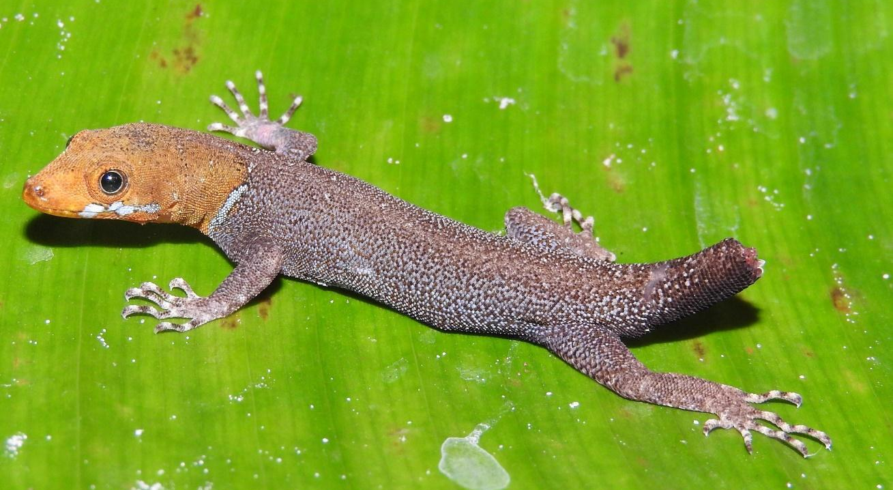
A
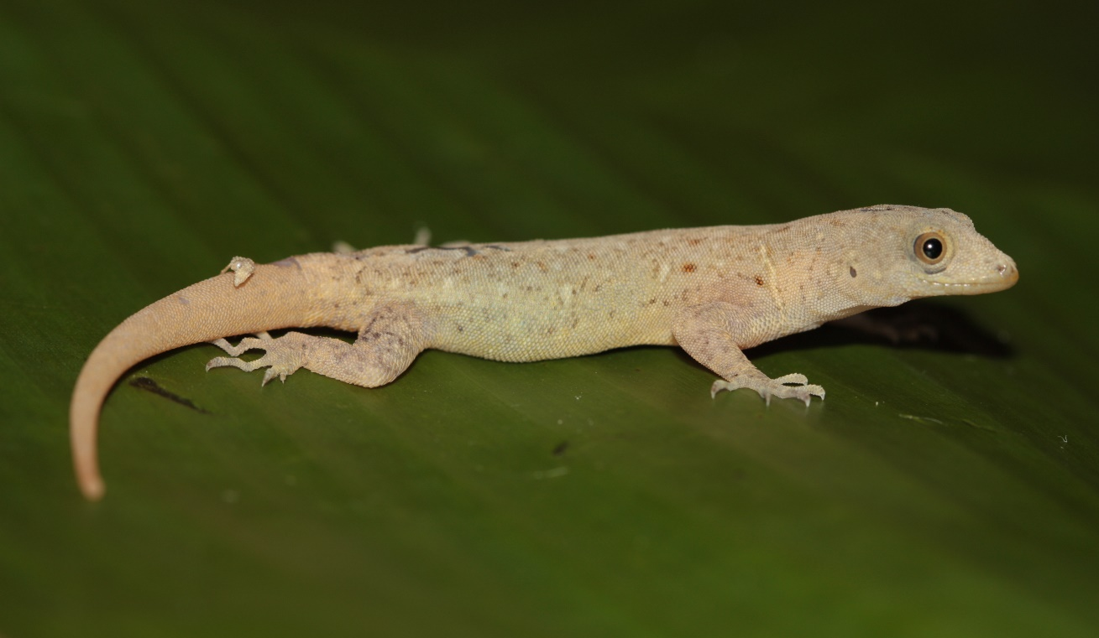
B

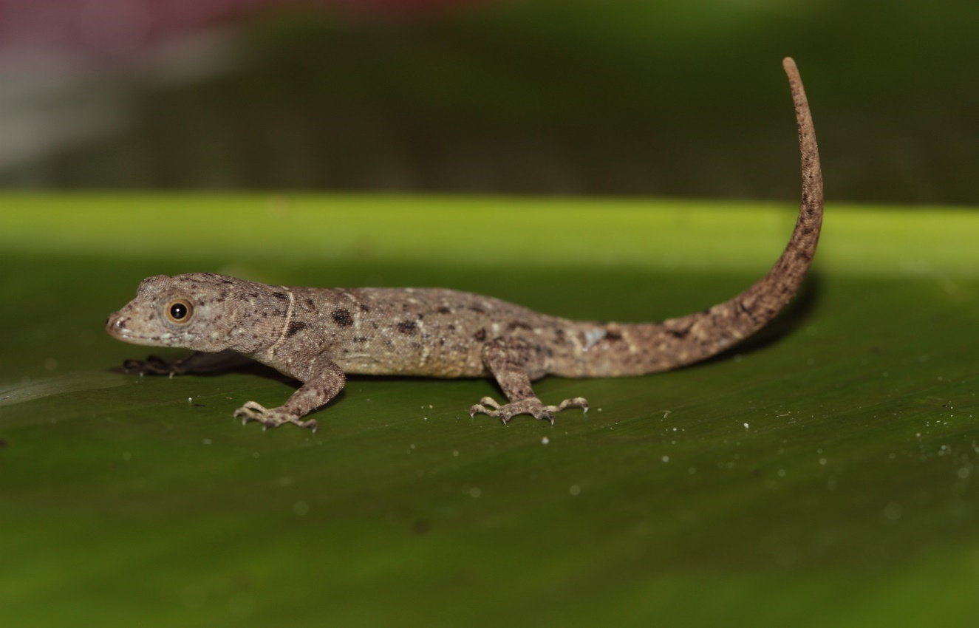

C
Figure 1. A. Male specimen of Gonatodes albogularis (SINCHI-R-389). B. Female with leucism specimen of Gonatodes albogularis (SINCHI-R-538). C. Female with normal coloration (SINCHI-R-541). The three specimens are from the city of Inírida, eastern Colombia.
Figura 1. A. Macho de Gonatodes albogularis (SINCHI-R-389). B. Hembra con leucismo de Gonatodes albogularis (SINCHI-R-538). C. Hembra con coloración normal (SINCHI-R-541). Los tres ejemplares son de la ciudad de Inírida, oriente de Colombia.

Figure 2. Cisandean distribution of Gonatodes albogularis in Colombia, showing previously known (black circles) and new records (red circles). Datum: WGS84.
Figura 2. Distribución cisandina de Gonatodes albogularis en Colombia, se muestran registros previamente conocidos (círculos negros) y nuevos (círculos rojos). Dato: WGS84.

